1. Go to Rhondda website - <https://maps.rctcbc.gov.uk/myRhondda.aspx>
2. Go to My Maps tap

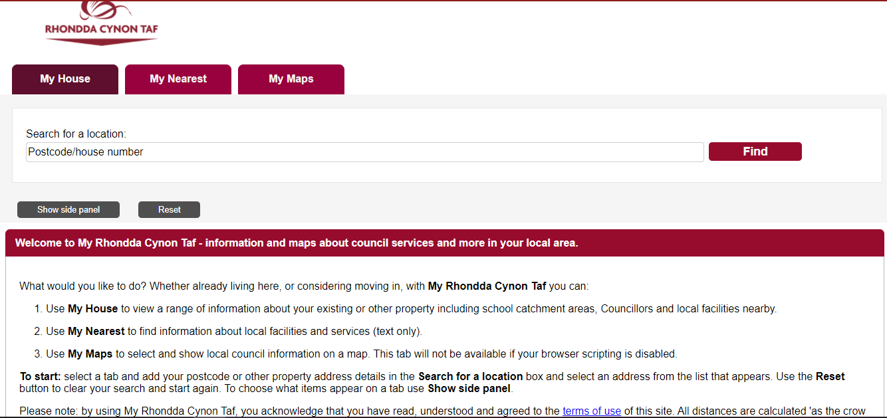

1. Paste the address copied from source file

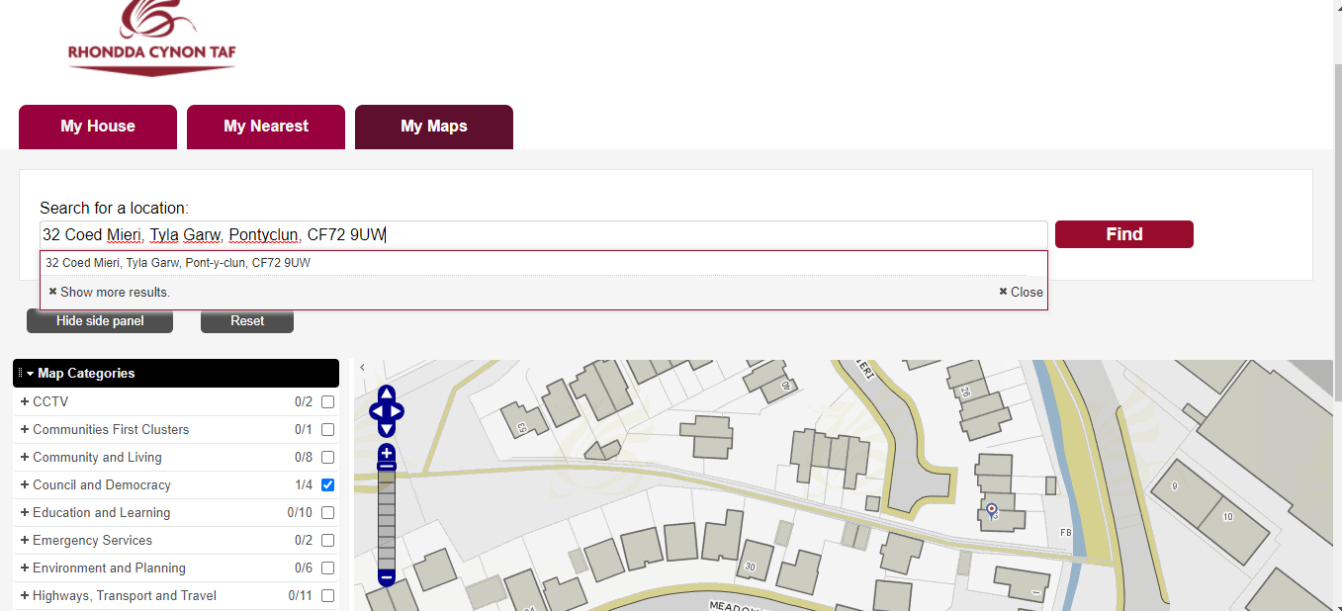

1. Select the correct address



1. Go to Environmental and Planning in side menu

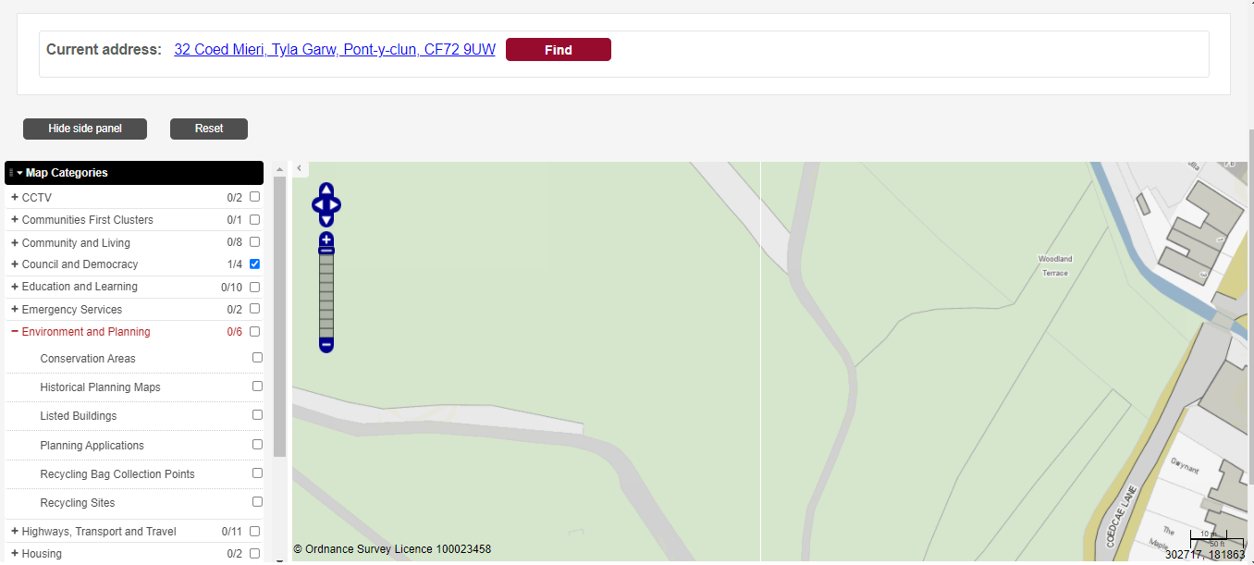

1. Select the Planning Application

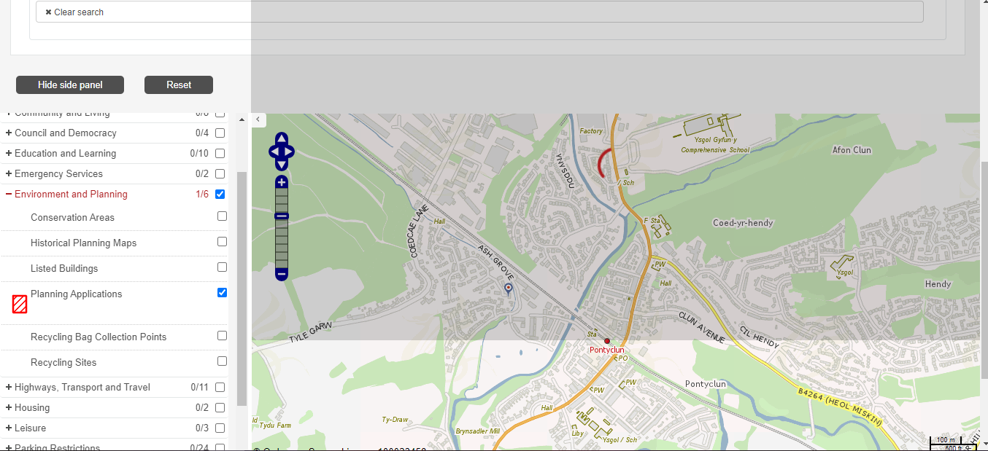

1. Double click on the highlighted area

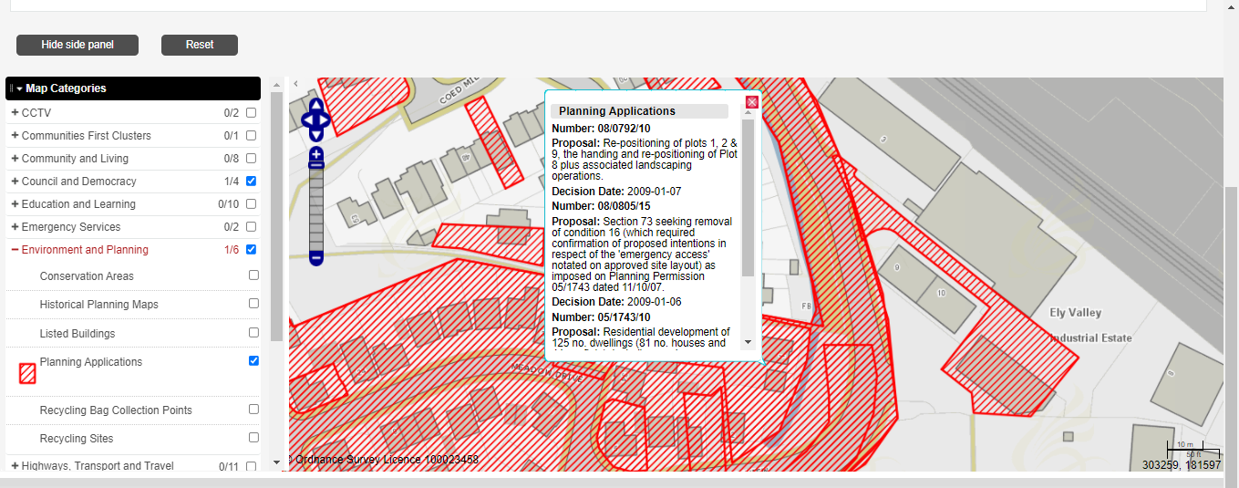

1. Copy all the information from the dialog box



1. Populate the details in excel file

